

**INSE 6400**

**Principles of Systems Engineering**

**Project Report**

***Concept development on “Car Sharing Services”***

**Submitted to Prof. Farnoosh Naderkhani**

**Submitted By:**

|  |  |
| --- | --- |
| *Name* | *ID* |
| ***Nirav Patel*** | *40029101* |
| ***Pradip Moradiya*** | 27717636 |
| ***Tapan kumar*** | 40071437 |

Table of Contents

1. Introduction 1

1.1 Problem Definition 1

1.2 Proposed System Capabilities 2

1.3 Project Objective and Scope 2

1.4 Need Analysis 2

Fact Finding 2

1.5 Context diagram 4

2. System Feasibility Analysis 5

2.1 Operational Feasibility 5

2.2 Technical Feasibility 6

2.3 Economic Feasibility 7

2.3.1 Net Present Value**:** 7

2.3.2 Return on Investment 8

2.4 Schedule Feasibility 11

3 Functional Analysis and allocation 12

3.1 Functional allocation 12

3.2 Functional allocation 14

3.3 Functional flow block diagram 16

3.4 System Operational Requirements 17

4 Decision making 18

4.1 Trade off Analysis 18

5 Conclusion 19

6 References 20

# Introduction

Cars became widely available in the early 20th century. One of the first cars accessible to the masses was the 1908 [Model T](https://en.wikipedia.org/wiki/Ford_Model_T" \o "Ford Model T), an American car manufactured by the [Ford Motor Company](https://en.wikipedia.org/wiki/Ford_Motor_Company" \o "Ford Motor Company). Cars were rapidly adopted in the US, where they replaced [animal-drawn](https://en.wikipedia.org/wiki/Draft_animal" \o "Draft animal) [carriages](https://en.wikipedia.org/wiki/Carriage" \o "Carriage) and carts, but took much longer to be accepted in Western Europe and other parts of the world.. People tend to use the fuel powered vehicle over bicycles because of the simplicity and also by considering the distance a vehicle could cover in short time.

Cars have controls for driving, parking, passenger comfort, and a variety of lights. Over the decades, additional features and controls have been added to vehicles, making them progressively more complex, but also more reliable and easier to operate. .Most cities like Montreal promote public transportation to reduce the traffic congestions and also offers car on rent to facilitate easy city rides.

Considering the sustainability impacts, this mode of transportation could bring back a change on travel time as they are fast and also offers more comfort. Today we have different kind of cars each serving different purpose. For instance, one who drive in racing use cars that are different from the ones designed for streets.

With the evolution of cars, they also tend to become more expensive than they used to be. On this regard, it’s not always practical for people to own different cars serving different purposes. This thought has greatly influenced us in working with an idea of generating an application where people could offer to rent out their car when they don’t use them.

## Problem Definition

There are lot of car owners in every city and hence we also have a huge list of potential renters among these car owners. Not everyone uses their car every day. The app will act as a platform which facilitates these car owners to rent out their cars.

From our point of view, most car owners are facing certain pains as stated below

* car owners don’t have any existing platform to rent out their cars
* It’s not always affordable for people to own different car that serve different purpose
* Many car owners tend to buy new car in few years considering several factors such as availability of parts, market trend etc.
* Could not always carry their car while travelling

## Proposed System Capabilities

In order to validate our hypothesis, we decided to interview people with right customer persona as potential users for this application. With the interviews, we figured out that most car owners are not interested renting out their car as they are concerned of theft or physical damages to their car. In order to address this concern of car owners, we decided to introduce an optional Insurance coverage for the car registered for rental in the application.

The application will ensue secure transactions and also blocks certain amount from the pre-authorized credit card of car users to address the security reasons. This could facilitate a safe and secure way of car rentals.

Making a tie with local car repair shops to facilitate discounted service for our car owners is also a goal of our application. With successful collaboration with manufacturers and service centers, customers could avail a discounted price for the spare parts.

## Project Objective and Scope

The following falls under our objective and scope

* + - Affordability: - The system should be affordable and economical as we are targeting every common man of the society.
    - User friendly interface: - The user interface should be friendly for both customers and car owners. It is even possible for the car owners to be our potential customers or users. Hence the application should concentrate on rental service
    - Coverage: - Popularity of the application is the key to success. The more customers we have, the more coverage we make. As the application is rental oriented, the key to success is dependent on the number of customers we have.
    - Scalability: - The application should be capable to accommodate future upgrades

## Need Analysis

### Fact Finding

Fact finding is the process of identifying and evaluating the needs of proposed system in order to map it to more specific system level functional requirements that would enlighten the concept. Market research,

Surveys, questionnaires, and customer interviews are generally used for fact finding. The outcome from these techniques are analyzed further to reach an optimum solution.

We conducted customer interviews to identify the approach of customers towards the concept of car sharing. Most of the questions we had were addressing the pains that customer face while using/renting cars. We decided to frame different set of questions for Owners and users as they have different aspects to the same problem. Few questions are as stated below.

*Set 1- (For car users)*

* + - Have you ever used car rental services?
    - How do you feel about it?
    - Did you face any difficulty or any challenge using those services?
    - Would you prefer different type of car to ride, instead of same type of car every time? Is this a deal breaker for you?
    - Have you ever needed to rent a car for one or more days?
    - Do you want to ride a car to another city/ countryside sometimes?
    - Do you use the car in winters?

*Set 2- (For car owners)*

* + - Do you have a car?
    - Would you like to rent your car for short period when you are not using it? / Do you want to make money by renting your car whenever you are not using it?
    - What would prevent you from renting your car out to others?

The feedback from customers has greatly influenced our decisions especially the one to add insurance on car to mitigate the customer concerns on theft and damages to car. We observed that most customers were hesitant to rent out their car as they were concerned about damages and theft. Cars owners being the most important part of our system, we considered this concern with utmost care

## Context diagram

The context diagram below shows interaction between the car rental services application and its external entities. Source of input in to the system and destination of output from system are the external entities and their interactions ae represented using arrows. In the direction of flow of interaction.

In this case, car user, car owner, payment gateway, customer services, car services and also insurance provider are external entities.

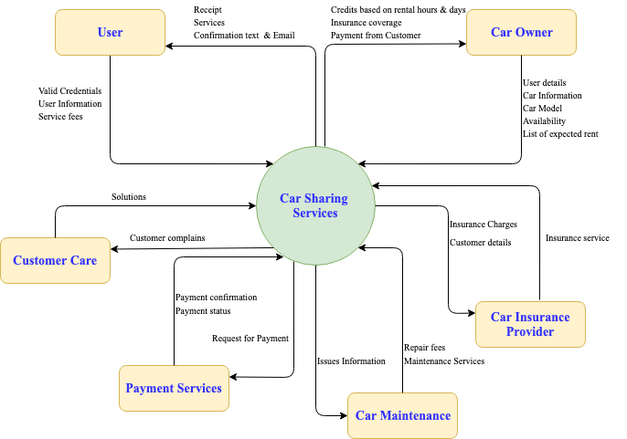

Fig: 1 Context diagram

We have also considered an option of adding and additional feature in the future which is car services. By generating a tie with different spare parts suppliers and also maintenance workshops, we could better assist our customers with discounted rates of repair and service.

This maintenance service providers could also be used to inspect the car before they are offered on rent. This could possibly improve customer satisfaction as we avoid possibility of renting out a damaged or faulty car.

# System Feasibility Analysis

Feasibility analysis determine the practicality of our project. In order to proceed operational feasibility, technical feasibility, schedule feasibility and economic feasibility are the key point which needs to be evaluated for the project. During analysis, we will be studying the existing similar systems in the market and how well we could modify its functionality to meet the requirements of conceptualized model.

## 2.1 Operational Feasibility

Operational feasibility analysis to determine effectiveness once it is implemented. We are assessing how well our system could solve the existing problems that our customers face and also how the system efficiently utilizes the opportunities available.

We have to check whether the customer is truly needing a change or not. The framework may be achievable on the off chance that it could carry a few favorable circumstances to the current framework. For our situation, while considering the input we got from customer reviews, the application is achievable as it could spare time and exertion for customers, the application will be easy to use and henceforth isn't requesting any extra preparing to its customers.

|  |  |  |  |  |  |  |  |
| --- | --- | --- | --- | --- | --- | --- | --- |
|  | **Weight** | **User Registration** | **Credit Card Verification** | **Add New Car** | **Search Car** | **User communication& Requests** | **Payments** |
| **Performance** | **5** | 4 | 3 | 3 | 4 | 3 | 4 |
| **Economy** | **3** | 3 | 3 | 3 | 3 | 2 | 3 |
| **User Friendliness** | **5** | 5 | 4 | 5 | 5 | 3 | 4 |
| **Efficiency** | **4** | 3 | 5 | 4 | 3 | 2 | 5 |
| **Services** | **3** | 2 | 4 | 2 | 2 | 2 | 3 |
| **Weight** |  | 72 | 76 | 71 | 72 | 50 | 78 |

Table 1: Operational Feasibility

We played out a weighted scoring model to break down various parameters and comparing highlights. From the above table, it could be seen that most highlights aside from the client communication and requests are operationally feasible. On this respect, we adequately use our assets for highlights that are operationally doable. The user communication could in any case be made with emails at least for the initial phase of app development instead of implementing online chat support/message with notifications etc.

## Technical Feasibility

While performing technical feasibility analysis, we have to ensure that there are sufficient assets and furthermore equipment bolsters accessible to execute the project. The unwavering quality of existing assets and need of any outer specialized ability likewise must be considered.

We led the weighted score and PERT investigation to assess the specialized attainability of proposed frameworks. The result demonstrates that every one of the highlights aside from user communication and requests could be actualized without the utilization of any hired external resources by simply utilizing the present current team of developers and testers. As the user communication isn't operationally doable, we could presume that it isn't actually attainable to enlist extra assets to execute messages/online chat support backing to the application in the underlying stage. This highlights are not attainable could be considered for future updates and improvements.

|  |  |  |  |  |  |  |  |  |
| --- | --- | --- | --- | --- | --- | --- | --- | --- |
|  | **Weight** | | **User Registration** | **Credit Card Verification** | **Add New Car** | **Search Car** | **User communication& Requests** | **Payments** |
| **Available Resource** | | **5** | 5 | 5 | 5 | 5 | 2 | 5 |
| **Easily Applied** | | **3** | 4 | 4 | 5 | 4 | 3 | 4 |
| **Upgrade Possibility** | | **4** | 4 | 5 | 4 | 4 | 3 | 4 |
| **Technical Expertise** | | **4** | 5 | 5 | 3 | 3 | 4 | 4 |
| **Technical Monopoly** | | **2** | 2 | 2 | 2 | 3 | 5 | 3 |
| **Weight** | |  | 77 | 81 | 72 | 71 | 57 | 75 |

Table: 2 Technical Feasibility

## Economic Feasibility

Economic feasibility analysis is performed to assess if the normal returns or advantages exceed evaluated cost to create and launch the application with accessible resources. All assets, for example, people, hardware and software requirements, formal and casual training, licenses charge, office costs and so forth are considered while playing out this assessment. The table below shows anticipated expense of executing the venture.

|  |  |  |
| --- | --- | --- |
| **PORJECT IMPLEMENTATION TOTAL COST FOR PROJECT** | | |
|  | **(Employee)** | **DEVELOPMENT** |
| A) | Development Manager | $8,000.00 |
| B) | System Architecture | $6,000.00 |
| C) | Team Leader | $7,000.00 |
| D) | Designing engineer | $5,000.00 |
| E) | Software Developer | $5,500.00 |
| F) | Tech Support | $4,000.00 |
| G) | System Analyst | $4,700.00 |
| H) | Software Tester | $4,500.00 |
| I) | Resources | $5,000.00 |
| J) | Licensing | $20,000.00 |
| K) | Administrative cost | $10,000.00 |
|  | Sub-Total Cost of Project | $79,700.00 |
| I) | Annual Maintenance Cost | $9,500.00 |
|  | **TOTAL** | $89,200.00 |

Table 3: Economic Feasibility

### Net Present Value**:**

We conducted an NPV analysis inorder to evaluate the feasibility of the project. Total cost of the project: **75700 CAD**

Annual maintance cost: **7500 CAD**

Interest rate: **10%**

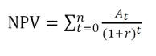

|  |  |  |  |  |  |  |
| --- | --- | --- | --- | --- | --- | --- |
| **PROJECT** | **YEAR 0** | **YEAR 1** | **YEAR 2** | **YEAR 3** | **YEAR 4** | **YEAR 5** |
| **REVENUE** | 0 | 45,000 | 50,000 | 55,000 | 55,000 | 70,000 |
| **EXPENSES** | 89,200 | 10,000 | 11,000 | 13,000 | 16,000 | 20,000 |
| **CASH FLOW** | -89,200 | 35,000 | 39,000 | 42,000 | 39,000 | 50,000 |
| **DISCOUNT FACTOR** | 1 | 0.9091 | 0.8264 | 0.7513 | 0.683 | 0.6209 |
| **NPV** | -89,200 | 31,819 | 32,230 | 31,555 | 26,637 | 31,045 |
| **Payback** | -89,200 | -57,381.50 | -25,151.90 | 6,402.70 | 20,234.30 | 10,810.70 |
| **NPV** | 30,232.70 |  |  |  |  |  |

Table 4: NPV analysis

The NPV is positive and hence we could proceed working with this project. It could be seen from the table that the project will be in profit from the 3rd year and hence there will be a positive payback from year 3.

### Return on Investment

|  |  |  |  |  |  |  |
| --- | --- | --- | --- | --- | --- | --- |
| **PROJECT** | **YEAR 0** | **YEAR 1** | **YEAR 2** | **YEAR 3** | **YEAR 4** | **YEAR 5** |
| **REVENUE** | 0 | 50,000 | 60,000 | 70,000 | 80,000 | 90,000 |
| **EXPENSES** | 89,200 | 10,000 | 11,000 | 13,000 | 16,000 | 20,000 |
| **Discounted Benefit** | 0 | 40909.5 | 41320 | 41321.5 | 37565 | 43463 |
| **Discounted Cost** | 89,200 | 9,091 | 9,090 | 9,767 | 10,928 | 12,418 |
| Total Discounted Benefits | | 204,579 |  |  |  |  |
| Discounted Costs | | 140,494 |  |  |  |  |
| ROI | | 46% |  |  |  |  |
| ROI = (Total Discounted Benefits – Total Discounted Costs)/Total Discounted Costs. | | | | | | |

Table 4: ROI analysis

From this analysis, the project is giving return on investment up to 46 % in about five years. Considering this, we could conclude that the project is economically feasible.

## Schedule Feasibility

In schedule feasibility, we dissect on the off chance that we could finish the task in satisfactory time rules. The chart below demonstrates the progression of procedure and furthermore the length of every action. The product application needs to go through beta testing before it is really launched to the market.

The overall duration of this stage is required to be 12 to about four months. From our analysis, the project is feasible, and the schedule could likewise be quickened further with additional assets without having any genuine effect on the overall product.

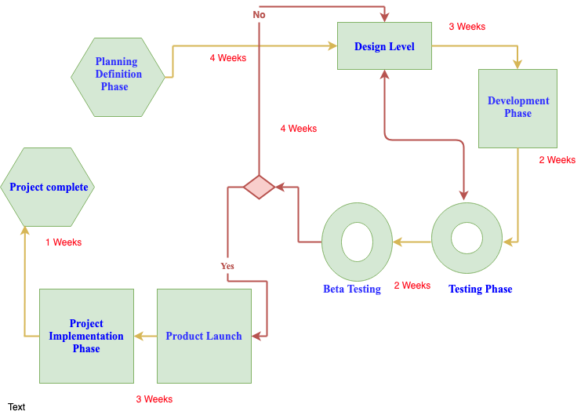

Fig: 2 Schedule feasibility

# Functional Analysis and allocation

It is a procedure of investigating the necessities and backing the effective and proficient planning of the car sharing services by characterizing the functional design of the system (Home). It is accomplished by utilizing the modelling techniques, for example, Functional tree and a functional structure chart. This analysis is performed to a profundity and is expected to help the synthesis.

In order to analyze, we identified all the lower level capacities are and sequenced them accordingly. These recognized capacities are essential for the satisfaction of the desired framework prerequisites with the goal that the framework can work sufficiently and adequately. This analysis is an iterative procedure. It is a fundamental part of both the Design and the Requirement circle.

## Functional allocation

This investigation causes us to perceive the sections (defining blocks) of the car sharing service and aides in subdivision of the system. This breakdown analysis guides us about, how the requirements of the service capacities are moved with a specific end goal to make or build the functional design of the car sharing service.

The below figure gives a brief description about the top level and also second level functions of the system. This method of car sharing services operation is used to define the hierarchy of different functional levels and demonstrates systems breakdown to the second level.

* + - Top level functions:

The user who tends to upload the advertisement posted generally needs to get registered with his name and id along with his payment details which are sent for verification. Once approved he gets to add his car with the minimum details and wait for a user to approach.

Concerning the customer or the client, he/she should have an account and be verified with the card or payment details get to search for the required or desired car and gets to communicate with the owner of the car and settle with a deal. The Payments are successfully accepted.

These functions that enables the interaction of application and the car user and car owner are considered to be the top-level function which the users of application are aware of. The communication between the user and owner either via email or messaging services in the application is also considered to be a top-level function.

System Top Level Functions

Add New Car Search Car

Credit Card Verification

Second level functions

Fig 3: Mode of operation/ functional breakdown

* + - Second level functions:

Goes deeper with how the verification is done and how the users or the clients are being verified in case of security. On credit card verification, payment authorization, insurance service and customer services. These functions work in the background even though users are not involved either directly or indirectly.

The mode of operation figure shows the automated control of the car sharing service by the user, User can control all the desired features physically through application installed anywhere by selecting the respective inputs on the screen thereby enhancing the experience customer face while renting out cars.

Also, the features added to both the top level and second level functions incorporate all day, with security and payment details kept confidential with credit validity, credit verification and credit hold under the payment verification part. The authorization is done by the gateways and bank. Every car has an optional insurance covered and is discussed between the owner of the car (user) and the client about the insurance coverage feature and incase if the vehicle is damaged or lost, the customer service could assist the client with expenses related to repair or even compensation for a lost car. The client could give their review as negatives and positives feedback based on their experience. The customer service ensures client satisfaction to guarantee reliable services.

## Functional allocation

The entire car sharing services application is subdivided in to major systems and their subsystems. The functional allocation of this system is defined in the diagram below. The system is further divided in to five noteworthy subsystems such as mobile application function, user database, payment services, server management and administrative functions.

The mobile application functions are further sub allocated to define services for the car user and also the car owner. Most activities done by both user and also the owner are defined under this mobile application functions. It includes registration of new users, cars and also verification of authenticity of the credit card and also data provided. The issues reported by user and also the owner is also handled by mobile application services.

User database stores relevant information for user identification and also to enable access management and data flow within multiple operating systems the customer’s use. The server management allocation service handles the operating system compatibility and also connectivity to server and related back end services including cloud services.

The administrative allocation function deals with customer support and also the insurance and other related support services to the customers. The main goal of administrative allocation function is to ensure customer satisfaction.

Fig 4: functional allocation block diagram

## Functional flow block diagram

The system is generated with building blocks that provide an important insight of the whole system by examining the structural hierarchy of modern systems. It is the responsibility of a system engineer to recognize factors such as programing risks, technological performance limits and interfacing requirements and also to make tradeoff analysis among the different design alternatives. All the functions of system are basically classified as input functions, output functions and also the transformative functions that convert any inputs to deliver outputs.

Our system needs information to control its operation and also the operational objectives require sensing and communication as like input commands from users. We define what all functions the application should perform and also how well it should perform it. However, we are not defining how the system performs defined functions.

Fig 5: Functional block diagram

Functional block diagrams are physical or pictorial description of a system for providing a more realistic view of system to people even without technical expertise. In the above block diagram, we defined a general application that interacts with users to perform assigned functions. Here the user gives the input through his electronic device either to upload a car or as a client to use one. The input given from the application goes to the web server passes through the service gateway and all the inputs are stored in the user database and reflects to the user in his application. The service gateway enables interaction between the webserver aided by mobile application and also the user database, services, event coordinators etc. Transaction management blocks records any payments made and also process the payments or credit holds for both car owner and car users.

## System Operational Requirements

The system operational requirements specifies the conditions and the equipment, software support, etc. It also specifies how the system should be used and flow of the data and control through life-cycle of system.

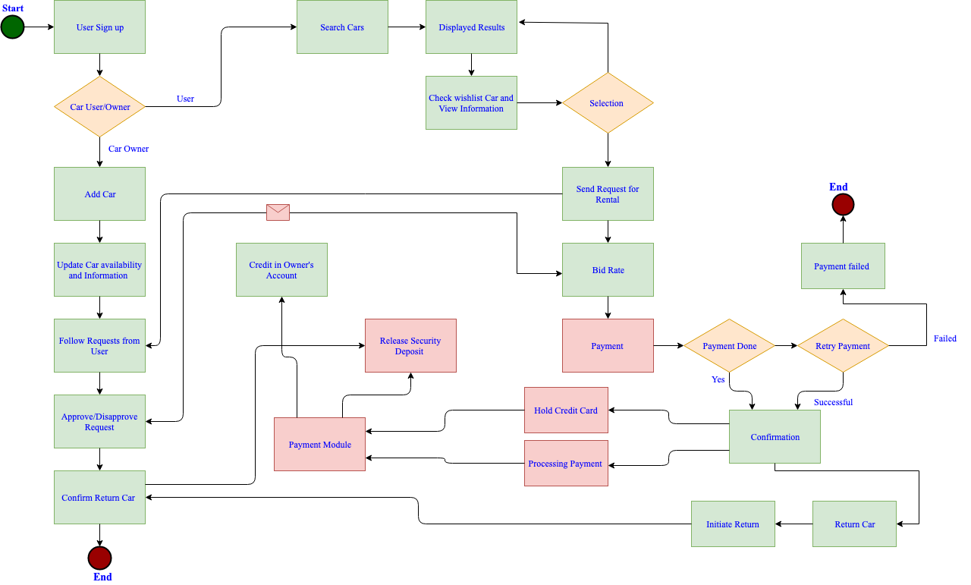

Fig 6: System Operational Requirements

# 4 Decision making

When the idea is characterized, we have to approve the possibility that is most applicable for the proposed undertaking. The ultimate result should just incorporate highlights that are possible and applicable to the extent the fulfillment of clients is concerned. So as to do this, we performed trade off analysis between different choices we had while developing building up this idea to finish up on the best one to approve the idea.

## 4.1 Trade off Analysis

Trade off analysis is basically assessment of goodness degrees to achieve an equalization among different goodness estimates based on the weightage we provide to each of them. While assessing we consider, we consider, performance, similarity, program cost and schedule and also the risk involved in achieving every one of these parameters. The proposed design feature has to be stressed to extreme limits to ensure that it is not just marginally satisfactory. As we are in the conceptual stage, approval can be considered as a bit of contention with some proof dependent on effectively existing solutions.

We decided to perform a tradeoff analysis with the options for providing Security to rented cars. The choices (alternatives) we had for this situation were

* Insurance
* User pays the deposit
* Freezing Credits as a deposit

We decided to rank them based on different criteria that could be a factor validating the concept based on evidence we see among the current rental services. The different criterions we considered to evaluate the tradeoff were as stated below

Criterion used

* Reliability of transaction- Terms & conditions involved
* Easiness-
* Time taken to return-
* Transaction Security- How secure it is
* Cost-Effectiveness – We must pay premium in case of insurance… for other transaction we don’t

have to pay fee

The table beneath demonstrates the tradeoff analysis we performed. Each criterion was given a weightage based on our knowledge about the existing solutions in the market. The highest weightage was defined for easiness of use followed by time consumed and also security in transactions. The least weightage was for transparency and also cost effectiveness of the feature.

|  |  |  |  |  |  |  |  |
| --- | --- | --- | --- | --- | --- | --- | --- |
|  | | **Alternative 1 (Insurance)** | | **Alternative 2 (User pays the deposit)** | | **Alternative 2 (Credit Freeze)** | |
| **Criterion** | **Weight** | **Value** | **W * V** | **Value** | **W * V** | **Value** | **W * V** |
| Reliability of transaction | 0.13 | 6 | 0.78 | 10 | 1.3 | 9 | 1.17 |
| Easiness | 0.27 | 4 | 1.08 | 7 | 1.89 | 9 | 2.43 |
| Time taken to return | 0.23 | 3 | 0.69 | 7 | 1.61 | 8 | 1.84 |
| Transaction Security | 0.18 | 5 | 0.9 | 9 | 1.62 | 10 | 1.8 |
| Cost-Effectiveness | 0.12 | 8 | 0.96 | 10 | 1.2 | 9 | 1.08 |
| Transparency | 0.07 | 6 | 0.42 | 9 | 0.63 | 7 | 0.49 |
| **Weighted Sum** | 1 | **4.83** | | **8.25** | | **8.81** | |

Table 5: Trade off analysis.

From the analysis, we determined that credit freeze is the most suitable mode we ought to deploy when compared to added insurance feature and also deposit feature. The least weightage is for insurance which make sense as it could be costly to offer insurance to each and every car after cautious assessment of the state of every car. Security deposits could also be inappropriate for users who don’t use the service very often and could also make new customers reluctant to resister in and use the car sharing service. On this regard credit hold features ensures that there remains security factor against misfortune/ damage and simultaneously would be helpful for clients as the sum on keep credits down in few working days and the client isn't really paying for it except if there is a case on harm/theft.

# Conclusion

After implementing methodologies studied in the course, we developed a Design concept of Car Sharing Services. The idea could hit the market to make an amazing throughput for the endeavors taken. The project is still in conceptual stage and we have to think about a few different viewpoints to guarantee fruitful finishing of the application.

This project has helped us to deduce

* + The interactions between different functions and components
  + Feasibility of Implementation

# References

1. “Car,” *Wikipedia*, 18-Aug-2019. [Online]. Available: https://en.wikipedia.org/wiki/Car.
2. Jorge Andres Barrios and Jean Doig Godier, “Fleet Sizing for Flexible Carsharing Systems: Simulation-Based Approach,” *ResearchGate*, Dec-2014. [Online]. Available: https://www.researchgate.net/publication/279227215_Fleet_Sizing_for_Flexible_Carsharing_Systems_Simulation-Based_Approach.
3. Q. Chen and T. Sun, “A model for the layout of bike stations in public bike-sharing system” *Journal of Advanced Transportation*, vol. 49, no. 8, pp. 884–900, May 2015.
4. https://[www.yelp.ca/search?cflt=carrentals&find_loc=Montr%C3%A9al,+QC](http://www.yelp.ca/search?cflt=bikerentals&amp;find_loc=Montr%C3%A9al%2C%2BQC) – car rental reviews
5. Luxembourg Institute of Science and Technology (LIST, “(PDF) Car-sharing services: An annotated review,” *ResearchGate*, Oct-2017. [Online]. Available: https://www.researchgate.net/publication/320698384_Car-sharing_services_An_annotated_review. [Accessed: 21-Aug-2019].
6. Yelp, “Top 10 Best Car Sharing in Montreal, QC - Last Updated August 2019 - Yelp,” *Yelp*, 2019. [Online]. Available: https://www.yelp.ca/search?find_desc=car%20sharing&find_loc=Montr%C3%A9al%2C%2BQC. [Accessed: 21-Aug-2019].
7. S. A. Shaheen and A. Cohen, “Carsharing and Personal Vehicle Services: Worldwide Market Developments and Emerging Trends,” *ResearchGate*, Jun-2012. [Online]. Available: https://www.researchgate.net/publication/241730570_Carsharing_and_Personal_Vehicle_Services_Worldwide_Market_Developments_and_Emerging_Trends.
8. “Bicycle-sharing system,” *Wikipedia*, 14-Aug-2019. [Online]. Available: https://en.wikipedia.org/wiki/Bicycle-sharing_system. [Accessed: 21-Aug-2019]